To do:
- Idea of preference as constructed at the choice
http://bear.warrington.ufl.edu/brenner/mar7588/Papers/slovic-ampsy1995.pdf
slovic 1995 – the construction of preference
- Finish off ideas in the conclusion
Appendix 1.2 – Where does value come from?
We open this thesis with the idea that utility is to choices as reproductive fitness is to innate behaviour. As genes give rise to phenotypes to maximise their reproductive success, some process in the brain is generating some internal sense of value that guides the choices an organism makes and the sense of reward, and thus reinforcement, they accrue from it. In the introduction to the thesis, we introduce the idea of utility, and the formalisation of Expected Utility Theory by von Neumann and Morgenstern (von Neumann & Morgenstern, 1944).
Though we think the results presented in this thesis have merit (and indeed merit the awarding of a doctorate) and show that the BDM mechanism can be used to glimpse the physiological substrate of utility, we are clearly only at the beginning of an arduous course of research to fully uncover the computations performed by organisms to make economic decisions; currently we only glimpse these through a scanner, darkly.
We use this thesis to place ideas and discussions we have had over the last three and a half years. These mostly boil down to the idea that if dopamine is ‘a neural substrate of prediction and reward’ (Schultz et al., 1997) then what does that mean. Obviously these questions are not limited to dopaminergic neurons (see appendix 1.3), and indeed we spend the end of this appendix discussing a similarly formulated question that focuses on the prefrontal cortices; ‘where does value come from?’ (Juechems & Summerfield, 2019).
Where does the theory of value come from?
For most people, considerations of value likely begin and end at the price of various consumer goods. Prices, and the willingness of consumers to pay them, are the signal by which the majority of the world’s economy is arranged, however, to a consumer they can seem as if they are divinely ordained. Some higher power has decided that good X costs £Y (give or take some small error between shops and over time). In order to explain how economies work, much of the history of economic thought has sought to explain this key signal: what leads an object to be labelled with a specific price?
‘Classical’ economic approaches to this question initially settled on the idea that value was intrinsic to the good being sold. Adam Smith originally formulated the idea that the cost of labour put into offering a good for exchange is “ultimate standard by which the value of commodities… can be estimated and compared”, later termed the ‘Labour Theory of Value’ (A. Smith, 1776). This was expounded upon by Ricardo who relaxed the theory stating that the price of a good is merely proportional to labour (Stigler, 1958). This idea of the value of a good being embodied by the cumulative labour necessary to produce it is a fundamental property of Marxist economic thought, with the difference between the value (i.e. the labour supplied) and the price of a good representing the surplus value (commonly termed S), i.e. the exploitation of labour (Marx, 1867).
At the very beginning of this thesis, we skip over this century of economic thought between Bernoulli’s formulation of utility vs value, and its rise to prominence in ‘neoclassical’ economics, among which is the idea that value is generated internally by a consumer. Furthermore, we only briefly touch on the neoclassical economic thought to discuss Edgeworth’s invention of indifference curves for choices (Edgeworth, 1881) and do not consider the prices of goods in the market.
Two other proponents of this school were William Stanley Jevons, who in 1862 (published Jevons, 1866) outlined the idea of marginal utility as the driving force behind prices, and Léon Walras, who took this idea further with his idea of a ‘general equilibrium’ (Walras, 1874). In such an equilibrium, each subject maximises their utility while ‘clearing’ a market (i.e. there is no leftover supply or demand in the economic environment). Such a toy equilibrium is shown for two monkeys trading bananas and apples in figure a2.1, extending Edgeworth’s portrayal of indifference curves illustrated in figure 1. The marginal utility of each good, represented by the indifference point, is the key contributor to each monkey’s demand for the two fruits provided which along with the initial allocation (the supply) will give rise to prices. This role of marginal utility in determining the demand for goods is key to solving Adam Smith’s ‘diamond paradox’. Though the first unit of water supplied to a dehydrated person is worth more than the first unit of diamonds, in general water is plentiful, so an additional unit of diamonds contains more marginal utility
The capstone of Walras’ theory of value were extensions by Ken Arrow and Gerard Debreu in their 1954 model of general equilibria in markets, for which the former won the Nobel prize in economics in 1972 (Arrow & Debreu, 1954). Arrow and Debreu showed that, with some assumptions, a competitive market should arrive at prices which balance the supply and demand (i.e. the utility) of goods across the entire range of products.
Overall, the neoclassical school of economics and their ‘marginal revolution’ showed that goods do not have an intrinsic worth. As Carl Menger stated (Menger, 1950):
“Value is thus nothing inherent in goods, no property of them, nor an independent thing existing by itself. It is a judgment economizing men make about the importance of the goods at their disposal for the maintenance of their lives and well-being. Hence value does not exist outside the consciousness of men”
Do we like value or do we want it?
The idea of utility as something internal to an individual’s mind remains a key tenet to economic thought. However, it raises the question of where this utility arises from. Throughout the main body of this thesis we dodge this question, regarding animals as ‘utility maximising’ computers who will seek out the greatest reward (defined as anything which reinforces the behaviour to receive said reward). For the study of whether and how monkeys perform auction tasks and the correlates of dopaminergic neuron firing during these tasks, this is a satisfactory definition. For this reason, experiments of reward use objective dimensions of reward, in this case, the magnitude of juice offered, but also commonly, the probability or even the quantified nutritional content (Grabenhorst & Rolls, 2014). More certain and larger rewards containing necessary nutrients are dominantly rewarding over those that are less likely to be delivered, are smaller, or do less to satisfy basic physiological needs. We ‘want’ to maximise the rewards we obtain in the same way that a computer program ‘wants’ a higher score on a video game (Mnih et al., 2013) or to win a game of chess (Silver et al., 2018).
However, in practice humans and other animals do not spend their entire lives chasing rewards. When possible, that is, when the organism has accumulated enough of these base desires, organisms can expend the temporal, social, or indeed monetary capital. Indeed, in the colloquial usage of the word ‘reward’, many of the experiences people list as the most rewarding (such as travelling and time spent with partners and family) revolve around experiencing pleasure unrelated to physiological needs. Even when these ‘wanting’ and ‘liking’ overlap in a single good it is relatively clear that they are not the same thing. For instance, when viewing films at a cinema, the author regularly takes along a large bag of sugary sweets. Though he is able to space the first few out across many minutes and enjoys the pleasurable sweet taste of them, invariably by the end of the first hour or so this is replaced by a craving to continue eating even as the ‘liking’ response has been diminished or perhaps even reversed.
This idea of ‘wanting’ and ‘liking’ being dissociable concepts first arose in neuroscience to explain the lack of impact of 6-OHDA dopaminergic neurons on rat’s ability to taste (Berridge et al., 1989). Though the lesions led to deficits in rats’ drinking and eating behaviour, they were still able to differentiate between tastes and retained their palate. I.e. the rats still ‘liked’ the taste of pleasurable food sources, but no longer ‘wanted’ them (in contrast the gluttonous author in the cinema). Similar findings have been reported in humans where catecholamine treatments (Leyton et al., 2005) and pimozide application (Brauer & De Wit, 1997) reduce the craving for drugs such as cocaine and ecstasy, but not the euphoric feeling elicited when the drugs are taken.
If it seems as though midbrain dopaminergic systems mediate the ‘wanting’ of potential utility (see also chapter 1 and discussions of hypersexuality and gambling disorders in treated Parkinson’s patients), which brain areas are implicated in ‘liking’ experienced utility? Studies measuring hedonic impact via conserved facial reactions to pleasurable, sweet stimuli involve the injection of either a control liquid or mimic of endogenous neurotransmitters to see the effect drugs have on an animal’s reaction to a stimulus. These studies have implicated the medial shell of the nucleus accumbens (Peciña & Berridge, 2005), and the ventral palladium (K. S. Smith & Berridge, 2005) in the ‘liking’ component of utility. Human lesions of the ventral palladium have also been known to lead to apathy (Adam et al., 2013) and anhedonia (Miller, 2006) supporting these findings.
An intrinsic problem of trying to measure this experienced utility (even more so than for our simple definition of utility used in the main body of this text!) is that, by its nature, these are highly subjective feelings. A bag of sweets can be rationally said to have more utility than a single sweet to the author as he enters a cinema foyer, but exactly how pleasurable is the act of chewing each? fMRI studies have attempted to study this by presenting a stimuli and then modulating the experience of it. For instance by ‘revealing’ that an odour comes from either expensive cheese or an unwashed body (De Araujo et al., 2005), or that a glass of wine is from a cheaper or more expensive vintage (Plassmann et al., 2007). In such studies, changes in the subject’s experience of the stimuli is correlated with BOLD activity in the orbitofrontal cortex, suggesting a role for this in the ‘liking’ component of utility.
We feel as though currently the evidence of these two streams of utility is unconvincing and yet to provide a compelling causal link between an experimental manipulation and the dissociation of ‘liking’ versus ‘wanting’ behaviours. We are, however, sympathetic to the difficulty of such experiments (how can one get an accurate behavioural report of an animal’s pleasure in the moment?) and to the idea that predicted and experienced utility as different. For instance, in human Parkinson’s patients treated with deep brain stimulation to recover dopaminergic activity, it seems as though self-stimulation relieves a pre-hoc craving, rather than providing a pleasurable post-hoc experience (Berridge & Kringelbach, 2011).
Where does value come from?
If wanting and liking are separable, do we value goods because we like them, or because we want them? A recent perspective by Keno Juechems and Chris Summerfield tends towards the latter- that the utility of a good or choice to an organism reflects the distance it closes between the animal’s current state (hunger, thirst, boredom, etc.) and some multidimensional goal state (Juechems & Summerfield, 2019). Such models are ‘homeostatic’ in that they incentivise organisms to choose options as if taking the shortest distance back to an ideal set point where basic needs are met (Keramati & Gutkin, 2014; O’Reilly et al., 2014).
The authors argue that their model is supported by recent data in which participants must balance the accumulation of assets along two distinct dimensions (filling a zoo with virtual lions and elephants; Juechems et al., 2019). The ventromedial prefrontal cortex tracked the progress towards redressing the balance of animals rather than the quantity of goods (animals) received per se. Crucially, this highlights a weakness in many economic decision-making paradigms where
When studying human economic behaviour, we have access to a well-studied and characterised signal of value- the price of a good. We spend a whole chapter defining the BDM auction task in this thesis partly to explain and justify its use, but to make it clear that we can experimentally access this continuous signal. Even though this project only deals with one animal and one manipulation (the volume of the good offered) of one kind of good (liquid rewards), there is no inherent reason to limit the paradigm this way. Early marginal revolutionists realised that these prices arise as a function of the fungibility of goods, for instance, with our hypothetical monkeys trading fruits in figure a2.1.
However, we do not think of such homeostatic models of reward as the universal solution to value that they have sometimes been portrayed as. In order to provide a weak criticism of these papers, a stronger version of the argument for such models can be expressed as follows (Damasio, 2009):
- Evolution guides systems towards those which will maximise the proliferation of the genes that produce a ‘beneficial’ phenotype. For an example from perceptual decision making, the statistics of natural visual scenes carry consistent and meaningful deviations from random noise. Evolution has left mammals with a primary visual cortex whose neurons show response properties that allow for the efficient coding of such scenes (Olshausen & Field, 1997), which aids the animal in deciphering the true visual state of the world. For economic decisions, evolution should also ‘guide’ neuronal processes to accurately quantify the decision variable, in this case value rather than light reflections.
- As far as the proliferation of a gene is concerned, a maximally ‘healthy’ organism is one that survives intact to adulthood and has the greatest chance of producing offspring that share its genetic code. From the gene’s point of view, the value of an object is the extent to which it can maintain its carrier’s life.
- The mechanism evolution has granted animals to maintain themselves on the organism level is via homeostasis. Therefore, from the point of view of the evolutionary systems which over many generations formed the neuronal mechanisms by which animals produce economic decisions, value is tantamount to homeostatic balance.
There is of course merit to the idea that some aspects of the value of goods come from biological necessity; to use the example from earlier in this section, a bottle of water is worth more to a critically dehydrated person than a diamond. It seems a stretch though to claim that just because an organisms valuation mechanisms evolved, that they are slaves to that evolution. To use an example from Juechems & Summerfield, it is tenuous to suggest that navigating networks was a crucial driver of how humans plan movement between two points, but millions of people successfully take the London underground each year using a nervous system that evolved over millions of year (c.f. the roughly 100 years the underground has been open; Balaguer et al., 2016).
Such caloric theories of value also preclude the idea of ‘liking’ aspect of choice we have discussed in the previous chapter. As earlier stated, we are not convinced that the ‘wanting’ vs. ‘liking’ paradigm is borne out by current evidence, but Juechems & Summerfield recognise that “some behaviours are driven by ‘liking’ alone”. Anecdotally, the author has hobbies which contribute precisely zero balance to his homeostatic balance or reproductive fitness. As mentioned, the literature on purely hedonic activity is sparse, but see for instance that video game players will frequently miss meals (a surely lower physiological drive; Deleuze et al., 2018) and that participants will give themselves electric shocks, which they had previously declared a disutility for in dollar amounts, when left alone with nothing else to do (Wilson et al., 2014). These findings can of course be interpreted as ‘goal-directed’ (such video game players are usually classified as addicted; relieving boredom might be a basic physiological need for any conscious animal) though in turn neuroscience should take care not to fully reverse the “reverse fundamental attribution error” (O’Reilly et al., 2014) ant attribute every behaviour to progress towards an organism’s goal.
Why do we study value?
Our aim in this appendix is not to unduly criticise this ‘top down’ approach to identifying how and why animals are able to make economic decisions. On the contrary, as the field further characterises the responses of neurons and brain areas to evermore complex economic tasks, such papers which can tie together disparate findings will be crucial. Indeed, while accurate characterisation of the cellular processes and computations which underlie valuation behaviour are and will be the bedrock of ‘neuroeconomics’, it seems unlikely to us that scientists go into the field purely for the technical challenge in untangling cellular signals.
A major appeal of ‘neuroeconomic’ research is that the role of the dopaminergic system in operant conditioning is perhaps the best understood example of abstract (i.e. not perceptual) processing in the brain. As “the poster child for Marr’s three levels of scientific enquiry” (Niv & Langdon, 2016), we have a well defined algorithmic (see equations 1.7 and 1.8) description of how a biological agent should update their beliefs about a rewarding (or aversive) stimuli with functions that are somewhat mirrored in the behaviour of midbrain dopaminergic neurons (the ‘implementational’ level). As progress continues along these levels in economics/computer science and neurobiology, articles which seek to define what the goal of such systems could or should be will be a vital companion.
We also feel that when making this progress, the field could
[perceptual stuff]
- Vision studies of deep rl to maximally trigger visual cortex -> can we do the same for dopamine? What about efficient coding? – Niv opinion piece 2015

In this appendix we have also explored the idea that the value and organism places upon a reward can be split into differentiable ‘wanting’ and ‘liking’ aspects. If this hypothesis is true, it raises the question of whether and how these two aspects are represented differently within the brain. In the context of this thesis, do dopaminergic neurons encode both ‘wanting’ and ‘liking’ and if so, are they encoded within the same neurons, or a separate population?
Topological maps and phasic liking vs tonic motivation?
Finally, if the multiple facets of subjective value we have posited in this chapter do exist, there are interesting implications about how our understanding of the brain generating values can inform policies. If we could accurately measure the “wanting-liking gap” (Camerer, 2006) then should government ‘nudge’ their citizens towards what their citizens ‘like’ versus that which they ‘want’. For instance, the author enjoys being fit and doing exercise, but typically finds themselves at about midday wanting cheeseburgers for lunch. In reinforcement learning, agents are usually trained with the policy to maximise some quantitative measure (e.g. points on a video game).
Can value studies help build wanting vs. liking RL agents? – dayan paper 2001ish
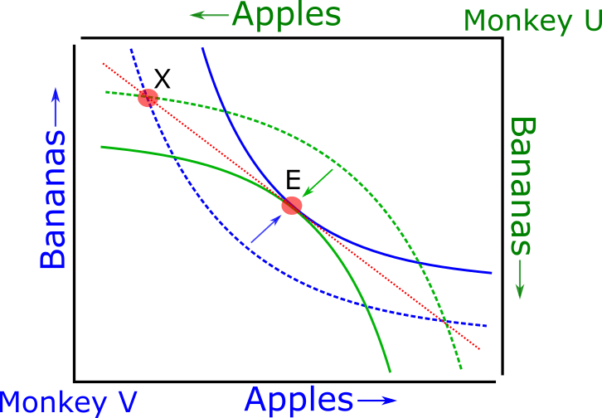
Figure a2.1 Neoclassical theories of utility provide the framework for Walrasian equilibria. Imagine our monkey from figure 1 choosing between apples and bananas has a partner, and we name these monkeys ‘Monkey U’ and ‘Monkey V’ (in line with the results chapters of this thesis). Both monkeys have indifference curves between apples and bananas as in figure 1 (blue and green; in this case symmetrical, though in practice probably unique to each organism). An initial allocation of apples and bananas ‘X’ leaves Monkey V with more bananas than apples, and vice-versa for Monkey U. These allocations lie upon indifference curves of low utility for both animals (dashed lines). A Walrasian equilibrium can be found where the monkeys trade the good they have a surplus of for the other, up to a point which lies upon the indifference curve representing the maximum achievable joint utility for both monkeys (‘E’; solid lines). At point E, both curves intersect along a tangent (red, dotted line), the slope of which is equal to the ratio of the price for bananas and the price for apples (in terms of each other) for both monkeys.

Figure 2 – ask summerfield lab for permission for figure 2 from where does value come from
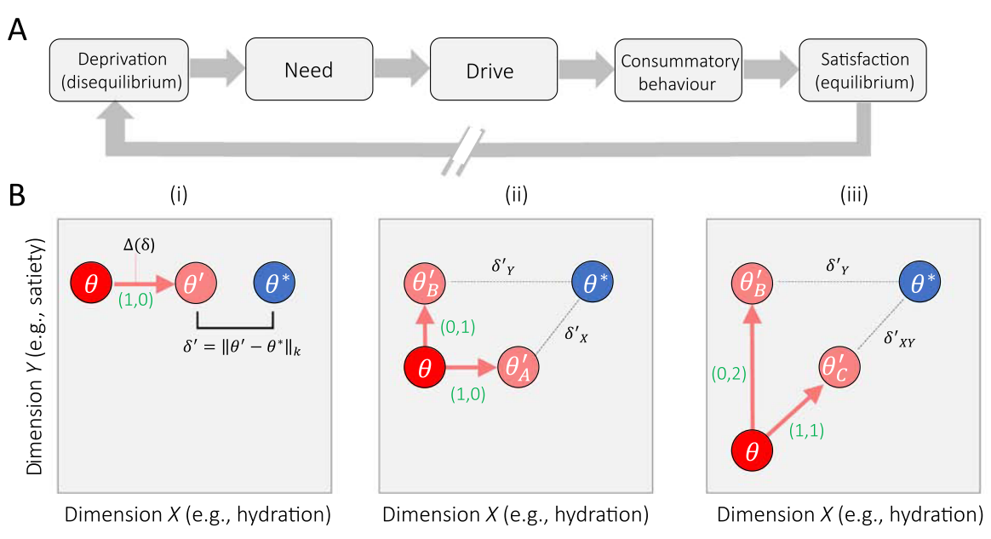
Figure a2.2

This framing in this thesis of most, if not all, of conscious human behaviour as making economic choices is partly done for hyperbole and may be contentious, but is not in itself wrong. ‘Economic imperialism’ has regularly claimed all purposeful (human) behaviour as under the field of economics (see Stigler, 1984). If all behaviour is economic, we find it amusing to wonder why so little is written on the ‘psychological/ethological imperialism’ of the minds that perform these choices, or even a ‘neuroscientific imperialism’ of the brain which must surely create those minds (for a more thorough and considerate discussion of the idea see Bujold, 2019).
Throughout the main text of the thesis, we try to only refer to ‘utility’ as the quantity maximised by our monkey’s making economic choices. Here we break from that somewhat and talk about ‘value’ to fit with the literature we will be discussing, and also because we want to use this appendix to digress and discuss the ideal of ‘value’ rather than observed measurements of ‘utility’
Though we prefer a simpler statement misquoted from a Clint Black song: “[value] isn’t something [an object] has; it’s something that we do”.
For a more recent review of the idea and criticism that goes beyond this appendix, see Berridge & O’Doherty, 2013.
This section is predominantly guided by the Juechems & Summerfield paper, in turn built upon a human fMRI paper which focus on the cortex. See Bogacz, 2020 for an interpretation of dopaminergic neurons in this context.
An example chosen as recent work has extended this ‘efficient coding hypothesis’ into the domain of experiments studying the behaviour of participants in an economic decision making setting (Polanía et al., 2019).
For the sake of argument, ignoring altruistic sacrifices but we can also assume these are done to pass on similar genes in the beneficiary population.
Obviously an anthropomorphism.
For the sake of brevity this argument ignores the evidence
Two caveats. Firstly, the mechanisms by which value is learnt in conditioning is not necessarily the same as how values are compared in economic choice behaviour. Secondly, it is rivalled by progress understanding episodic memory consolidation and retrieval in the mammalian hippocampus. See Tonegawa et al., 2015 for a review and Lisman, 2016 for a discussion of both of these systems within the context of Marr’s three levels.

